Software Development Lifecycle (SDLC) Analysis of Shopify

A Comparative Study of Different Models in Relation to Shopify's Software Development

Abhishek Acharya

NMAMIT

nnm23is003@nmamit.in

GitHub Repository:

Keywords: SDLC, Shopify, Ruby on Rails, Microservices, E-commerce, Scalability, Testing, Requirements validation

Abstract:

Software development is an evolving discipline requiring structured approaches for building scalable, secure, and efficient systems. This report explores the Software Development Life Cycle (SDLC) models applicable to Shopify, a global leader in e-commerce platform services. It provides a comparative analysis of SDLC methodologies and an overview of requirements engineering in the context of Shopify. The study aims to offer insights into the selection of an appropriate SDLC model for large-scale e-commerce platforms, emphasizing the waterfall, incremental development, and spiral model approaches. The report also discusses challenges and strategies involved in requirements validation and software deployment at Shopify. The findings in this document are based on extensive research, industry best practices, and insights from Shopify's technology stack. I hope this report serves as a valuable resource for software engineers, architects, and researchers interested in the intersection of SDLC methodologies and large-scale e-commerce platforms. This paper concludes with key findings and considerations for future development.

Publishing: This paper is hosted on a GitHub repository, along with the material used for preparing this research.

Contents

1. Introduction

2. Overview of Shopify

2.1 System Overview

2.2 Technologies Used

3. Comparative Analysis of SDLC Models

3.1 Waterfall Model

3.2 Incremental Development Model

3.3 Spiral Model

3.4 Summary of Comparison

4. Requirements Engineering for Shopify

4.1 Functional Requirements

4.2 Non-Functional Requirements

4.3 Requirements Validation Strategy

4.4 Challenges in Requirements Validation

5. Conclusion

6. References

1. Introduction

Shopify is one of the leading e-commerce platforms globally, offering online store creation and management capabilities to millions of merchants. The platform relies on a robust cloud-based infrastructure, primarily built on Ruby on Rails with a microservices architecture. Given its large-scale nature, Shopify requires an efficient software development lifecycle (SDLC) to manage continuous updates, new features, and system stability. This report conducts a comparative study of incremental development, spiral model, and waterfall model in relation to Shopify's software development. It also explores requirements engineering and the challenges faced by an e-commerce platform that serves businesses of all sizes, from small entrepreneurs to enterprise-level corporations.

2. Overview of Shopify

2.1 System Overview

Shopify provides a subscription-based platform for creating and managing online stores. The system supports multiple sales channels, customizable storefronts, inventory management, payment processing, and analytics. The service primarily enables merchants to sell products across multiple channels including web, mobile, social media, marketplaces, and physical retail locations. The platform is available internationally and supports multiple languages and currencies.

2.2 Technologies Used

Core Framework: Ruby on Rails

Architecture: Monolith transitioning to Microservices

Database: MySQL, Redis for caching

Frontend: React, Typescript, GraphQL

Infrastructure: Google Cloud Platform (GCP)

Containers: Docker, Kubernetes

Programming Languages: Ruby, JavaScript, Go, Python

DevOps: Continuous Integration & Continuous Deployment (CI/CD)

Version Control: Git

Shopify uses additional technologies across its platform, but these represent the core components powering the e-commerce system. Each component works together to provide merchants with a reliable, scalable platform for their businesses.

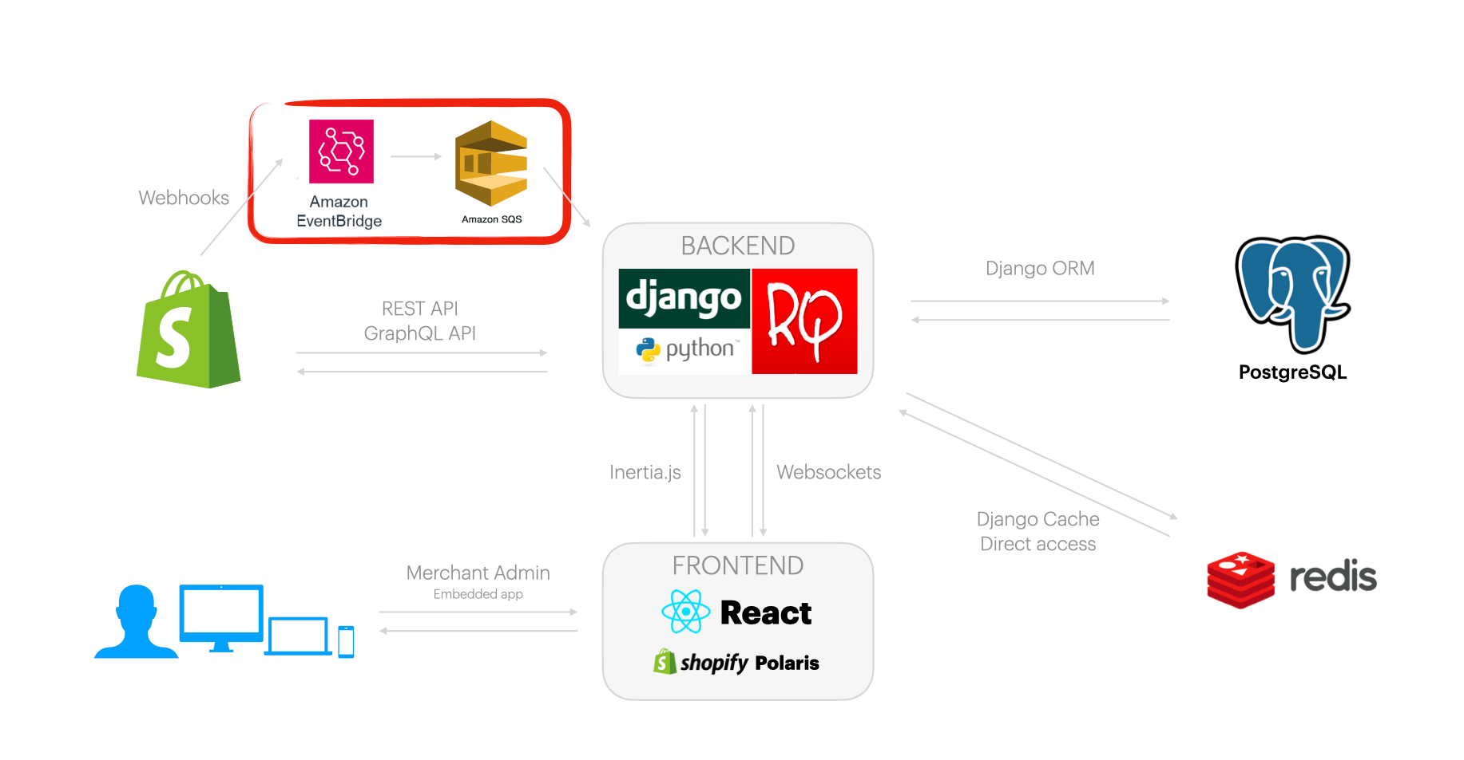 Shopify tech stack model

3. Comparative Analysis of SDLC Models

3.1 Waterfall Model

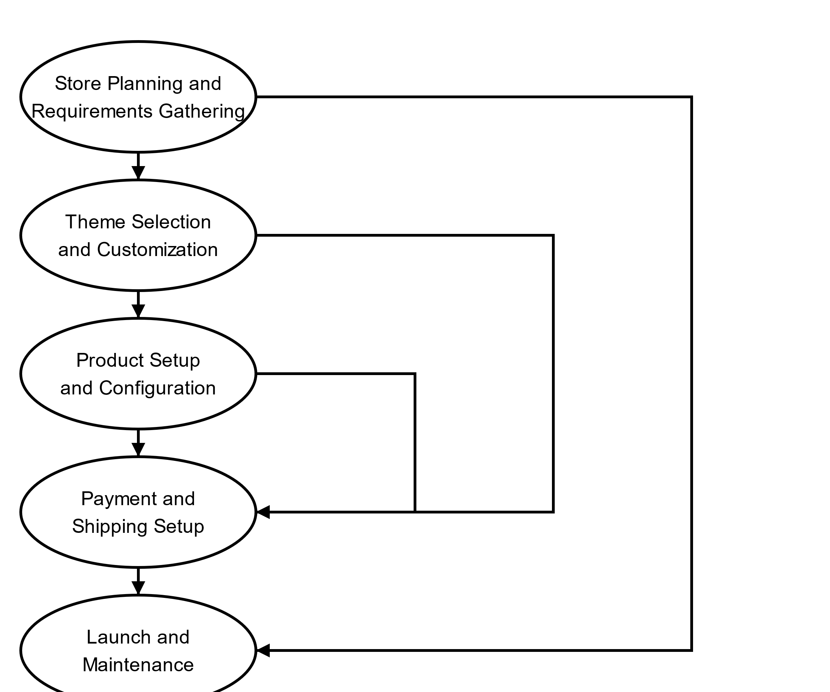

How Shopify Would Be Developed Using Waterfall:

1. Phase 1: Requirements Definition – All system requirements are defined at once. This includes defining merchant authentication, product management capabilities, checkout processes, and payment integrations. Since changes are difficult to implement later, exhaustive documentation is required at this stage.

2. Phase 2: System & Software Design – A complete architecture is developed, including all database structures, API endpoints, and infrastructure on Google Cloud Platform. Every aspect of the system is carefully mapped out before development begins.

3. Phase 3: Implementation – Developers begin coding the entire system at once. No changes to the requirements are permitted, and development follows a linear path.

4. Phase 4: Integration and System Testing – After development is completed, the entire system undergoes integration and rigorous testing. This includes functional testing, performance testing, and security testing. Since all components are built at once, identifying and fixing bugs can be time-consuming.

5. Phase 5: Operation and Maintenance – The fully developed e-commerce platform is deployed to production. Any bugs discovered post-launch are addressed during maintenance. However, because new changes require extensive planning and reimplementation, updates take a long time to roll out.

Suitability for Shopify:

1. Pros:

- Well-documented and structured approach ensures clarity in development.

- Separate and properly defined phases simplify project management.

- Suitable for smaller, well-defined projects with minimal expected changes.

2. Cons:

- Lacks flexibility for rapidly changing merchant needs.

- If issues are discovered later, it can cause significant delays.

- Long development cycles make it unsuitable for continuous updates.

- Difficult to adapt to changing e-commerce trends and regulations.

3. Verdict:

Not suitable, as Shopify requires frequent updates, rapid feature deployment, and adaptability to evolving merchant needs and market trends.

3.2 Incremental Development Model

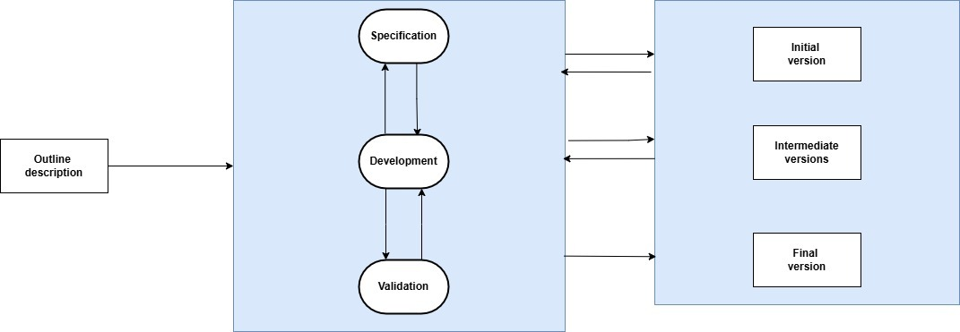

How Shopify Uses Incremental Development:

1. Phase 1: Planning and Initial Requirements – The development team identifies high-priority features, such as core store functionality, product management, and basic checkout. Only essential requirements for the first iteration are finalized, leaving room for future updates.

2.Phase 2: Feature-wise Development– Instead of developing the entire system at once, Shopify continuously releases new features such as improved analytics, additional sales channels, and enhanced inventory management. Each feature undergoes design, development, testing, and deployment in separate cycles.

3. Phase 3: Continuous Merchant Feedback – Each increment is deployed to beta merchants who provide feedback. Developers analyze this feedback and make necessary adjustments before launching to all users.

4. Phase 4: System Testing and Refinement– Every new feature undergoes extensive testing, including performance analysis, bug fixes, and security assessments. Automated pipelines ensure continuous integration and testing.

5. Phase 5: Deployment and Monitoring – Features are released to production in batches, ensuring minimal disruption to merchants' businesses. A/B testing is often used to compare different versions of a feature before full-scale deployment.

6. Phase 6: Iteration and Maintenance – This iterative process repeats as developers refine existing features, resolve merchant-reported issues, and introduce new functionalities based on changing market needs.

Suitability for Shopify:

1. Pros:

- Faster time-to-market with incremental feature releases

- Quick adaptation to changing merchant needs

- Continuous testing ensures reliability and better performance

- Easily scalable and supports cloud-based microservices architecture

- Allows for experimentation with new e-commerce features

2. Cons:

- Requires effective integration strategies to avoid system conflicts

- Needs strong version control mechanisms to manage multiple development branches

- Can become complex if too many features are being developed simultaneously

- Requires careful planning for backward compatibility

3. Verdict: Highly suitable for a large-scale, evolving platform like Shopify, as it supports continuous updates and merchant-driven enhancements while maintaining platform stability.

3.3 Spiral Model

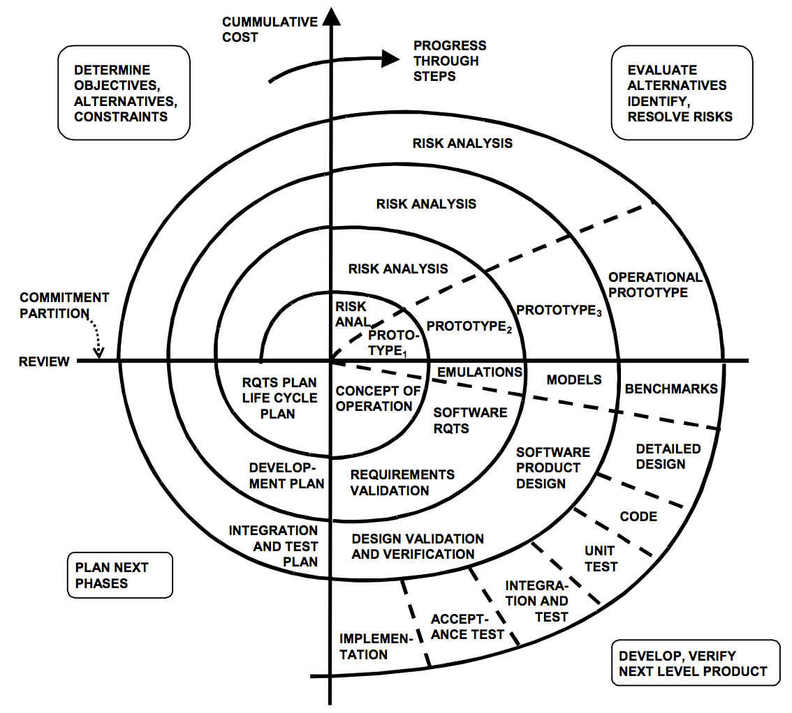

How Shopify Would Be Developed Using Spiral:

1. Phase 1: Risk Analysis and Prototyping – Prior to deploying significant features like payment processing or international tax compliance, Shopify analyzes the risks. This includes security threats, regulatory compliance, and performance concerns. Small-scale prototypes are developed first.

2. Phase 2: Concept Validation and Refinement – Prototypes are tested with select merchants, and the design is refined based on feedback. This iterative process helps validate features against technical limitations and business objectives.

3. Phase 3: Development and Testing – Features are built and tested in multiple cycles, with changes based on risk assessment and early merchant feedback.

4. Phase 4: Validation and Security Testing– Particularly important for complex features such as payment processing, fraud detection, and compliance with international e-commerce regulations.

5. Phase 5: Gradual Deployment – New features are initially deployed to a small percentage of merchants. Real-world performance is monitored, and adjustments are made before scaling to all users.

6. Phase 6: Refinement and Continuous Improvement– Developers use real-time analytics and merchant insights to refine features further. This cycle repeats for future improvements.

Suitability for Shopify:

1. Pros:

- Strong risk management ensures robust system development

- Iterative improvements help refine complex features like payment processing

- Suitable for high-risk functionalities such as security updates and compliance features

- Works well for features with regulatory or financial implications

2. Cons:

- Expensive and time-consuming for simple features

- Requires highly skilled teams to assess risks accurately

- Can be inefficient for routine updates that don't involve high-risk factors

- May slow down innovation in non-critical areas

3. Verdict: Suitable for high-risk features such as payment systems, security updates, and compliance implementations, but may not be necessary for routine feature development.

3.4 Summary of Comparison

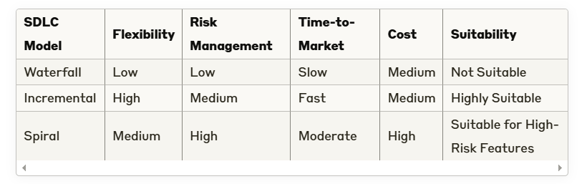

## 4. Requirements Engineering for Shopify

Requirements engineering is crucial for Shopify to deliver high performance, scalability, security, and an exceptional user experience for both merchants and their customers. This section explores the core aspects of Shopify's requirements engineering practices and the challenges associated with managing them for a globally distributed e-commerce platform.

### 4.1 Functional Requirements

These are the specific behaviors and functionalities that Shopify must support to meet merchant expectations:

- **Merchant Authentication & Account Management**: Secure registration and login using OAuth, multi-factor authentication, and role-based access controls for staff accounts. Support for multiple user roles within a single store (owner, staff, developer).

- **Product Management**: Support for physical and digital products, variants, inventory tracking, and bulk editing capabilities. Integration with inventory management systems and dropshipping suppliers.

- **Storefront & Theme Management**: Customizable themes with responsive design, content management system for pages and blogs, SEO optimization tools, and multilingual support.

- **Checkout & Payment Processing**: Support for multiple payment gateways, secure checkout process, abandoned cart recovery, discount codes, and tax calculation based on location.

- **Order Management**: Order processing workflows, fulfillment tracking, returns management, and integration with shipping carriers for label generation.

- **Analytics & Reporting**: Sales reports, customer insights, inventory forecasting, and marketing campaign performance metrics.

- **Multi-channel Selling**: Integration with social media platforms, marketplaces, and point-of-sale systems for unified inventory and order management.

- **App Ecosystem**: API infrastructure for third-party developers to build and integrate applications, with appropriate permission scopes and rate limiting.

### 4.2 Non-Functional Requirements

- **Scalability**: The system must handle traffic spikes during sales events without performance degradation. Auto-scaling infrastructure to accommodate growing merchant businesses.

- **Availability**: High uptime (99.99%+) through redundant systems and multi-region deployment. Minimal planned maintenance windows that don't disrupt merchant operations.

- **Security**: PCI DSS compliance for payment processing, data encryption at rest and in transit, fraud detection systems, and regular security audits.

- **Performance**: Fast page load times for storefronts, quick checkout process, and responsive admin interface even with large catalogs.

- **Compliance & Legal Considerations**: Adherence to GDPR, CCPA, ADA accessibility standards, and varying tax regulations across different countries.

- **Maintainability & Upgradability**: Support for continuous deployment and infrastructure upgrades without disrupting merchant businesses.

- **Disaster Recovery**: Comprehensive backup systems and recovery procedures to prevent data loss.

### 4.3 Requirements Validation Strategy

Shopify employs various techniques to validate software requirements:

- **Stakeholder Reviews**: Collaboration with merchants, partners, and internal teams to refine requirements.

- **Prototyping & A/B Testing**: Testing UI/UX changes with a subset of merchants before full deployment.

- **Automated Testing & CI/CD Pipelines**: Comprehensive test suites including unit, integration, and end-to-end tests to ensure quality.

- **Security Audits**: Regular vulnerability assessments and penetration testing.

- **Merchant Feedback Loops**: Collection of real-time analytics and direct feedback through support channels and community forums.

### 4.4 Challenges in Requirements Validation

Despite a structured validation approach, Shopify faces several challenges:

- **Diverse Merchant Base**: Balancing the needs of small businesses versus enterprise clients with different requirements.

- **Global Compliance Issues**: Adapting to different regional regulations, tax systems, and privacy laws.

- **Scalability During Peak Seasons**: Ensuring performance during high-traffic events like Black Friday and Cyber Monday.

- **Balancing Innovation with Stability**: Introducing new features without disrupting existing merchant operations.

- **Third-party App Ecosystem**: Maintaining compatibility with a large number of third-party applications while evolving the platform.

## 5. Conclusion

Shopify, as a continuously evolving e-commerce platform, benefits most from Incremental Development for rapid feature deployment and the Spiral Model for high-risk features like payment processing and security updates. The Waterfall model is not suitable due to its rigid structure and inability to adapt to changing market conditions. Shopify's effective requirements engineering process ensures that it meets both functional and non-functional demands while balancing the needs of diverse merchants across the globe.

## 6. References

1. Sommerville, I. (2015). Software Engineering (10th Edition).

2. Shopify Engineering Blog - https://engineering.shopify.com/

3. Shopify Dev Documentation - https://shopify.dev/

4. Google Cloud case studies on Shopify's infrastructure

5. Shopify Annual Reports and Technology Disclosures